**EAS 596 - CYBERSECURITY ANALYTICS**

**ASSIGNMENT 01**

**GROUP- 5:**

Ayyathurai Jaya, Raghavi Preeti

Heeb, Collin

Kandasamy, Kathiresan

Patnayakuni, Sharada

Pindi, Naren

**1) Create a search where you list out the top 10 goal scorers in the league, sorted from highest to lowest.**

**QUERY:**



**OUTPUT:**

**2) Create a search where you list out all NHL players, by team, who have one or more game winning goals. This should be sorted in alphabetical order of the teams.**

**QUERY:**

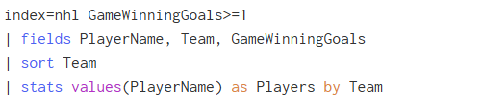

**OUTPUT:**

**3) Create a search where you list the top 5 teams that have the most penalty minutes. Rename the total count of penalty minutes per team as “Team_PIM”.**

**QUERY:**



**OUTPUT:**

**4) Create a table to show the total amount of points, per position, and sort highest to lowest.**

**QUERY:**

**OUTPUT:**

**5) Create a table to show, per each team, the total amount of goals that they have, the total amount of shots that they have, and what their shooting percentage is.**

**QUERY:**

**OUTPUT:**

